By Brittany Gullison

Jesse O’Donnell

Melissa Smith

Jason Wilson

Dr. Heather Richmond

EDUC 5813 28 February 2012

Table of Contents

Section 1: Introduction to Unit

* Rationale and Explanation of Unit................................................................................3
* Outcomes for the Unit.......................................................................................................4
* Evaluation...............................................................................................................................5

Section 2: Unit Materials

* Introductory Lesson....................................................................................6-9
* Lesson on Plot...........................................................................................10-13
* Lesson on Setting......................................................................................14-15
* Lesson on Character..................................................................................16-24
* Lesson on Conflict.....................................................................................25-28
* Sample Student Projects...........................................................................29-34
* Materials/Resources.................................................................................35-41
* Bibliography..............................................................................................42-43

Rationale and Explanation of Unit

In the ninth grade, student writing will hopefully be enhanced. In middle school, students have been exposed to the five paragraph structure and now that they’ve reached high school they are expected and encouraged to branch out of their comfort zones. Narratives provide a way for this to be done more readily than in expository writing. Narratives give the students opportunities to be creative and to take chances. As educators, we want our students to develop their own voices in writing.

While mini-lessons on grammar, spelling, and conventions are to be expected we wanted to focus on elements specific to the narrative. Conventions will be covered in multiple units because of their overall importance to writing. Here we break down the narrative into four areas: Character, setting, plot, and conflict. By the end of the unit we hope the students can show they understand the meaning of each and have employed them in their own narratives. The knowledge and skills required for writing a narrative piece will be provided through minilessons and workshop based classes.

The final assignment will be a narrative of the students’ own design. During the first class of the unit we will provide a maximum of 12 paintings/images. Each image is different and each student will have a chance to look at and analyze them during class. The exit slip for that particular class will be a one or two-sentence description of what the plot/story/idea of each painting is. For example, if one painting features a man alone in a boat in the middle of the ocean the student may describe this as: A man, James, is the only survivor of his sunken ship. He made it to a lifeboat and must find his way back to land before he dies of hunger or is eaten by sharks.

This brief description could be the beginning of a larger story the student pursues for his/her final narrative. The point is they will have choices, ideally 12 plots of their own creation that they can draw from to create a complete story.

Once students select their painting they will begin to develop a story based on that picture. Students will submit an outline of the story to the teacher and a rough draft before submitting the final copy of their narrative. They will learn how to develop and infuse plot, setting character and conflict in their story. Students will peer evaluate each other’s stories as they progress and the teacher will conference one on one with students to ensure understanding of the techniques and that curriculum outcomes are being met. It is recommended that students select one of the paintings provided be selected, but for purposes of differentiation and accommodation students can suggest other paintings to base their story or choose not use a painting as inspiration.

With each mini-lesson, the students should have a basic understanding on the four major elements of a narrative we’ve discussed and are expected to include them in their narratives.

We want to engage student creativity so they enjoy the project but also grow as individuals and improve their voices as writers. Writing can be a rewarding outlet and it shouldn’t be something students dread. This unit gives students an opportunity to try different ideas and techniques without being bound to a specific structure. It is still organized but there is more freedom. The teacher acts more as a guide to help promote student ownership. It should be a fun experience.

Outcomes for Unit

The following is a list of curriculum outcomes that will be met during the unit we have designed. These outcomes fall under the categories of general, key-stage and specific curriculum outcomes for Grade 9 English according to the Atlantic Canada English Language Arts Curriculum.

**Speaking & Listening**  
  
- Students will be expected to communicate information and ideas effectively and clearly, and to respond personally and critically.  
  
**Reading & Viewing**  
-Students will be expected to select, read, and view with understanding a  
range of literature, information, media, and visual texts.  
  
-Students will be expected to respond critically to a range of texts, applying  
their understanding of language, form, and genre.  
  
**Writing & Other Ways of Representing**  
- Students will be expected to use writing and other ways of representing to  
explore, clarify, and reflect on their thoughts, feelings, experiences, and  
learning; and to use their imagination.  
  
-Students will be expected to create texts collaboratively and independently, using a variety of forms for a range of audiences and purposes.

-Students will be expected to use a range of strategies to develop  
effective writing and other ways of representing, and to enhance  
clarity, precision, and effectiveness.

-Demonstrate commitment to crafting pieces of writing and other representations  
  
-Analyse and reflect on others’ responses to their writing and audiovisual productions and consider those responses in creating new pieces  
  
-Consistently use the conventions of written language in final products  
  
-To refine writing to enhance impact.  
  
-Write with purpose and understand the influence of the writer.  
  
-Independently reread, add to, delete from, or reorganize the text to clarify and strengthen  
content.  
- Create an organizing structure appropriate to the purpose, audience, and context of texts.

Evaluation

|  |  |  |  |  |
| --- | --- | --- | --- | --- |
| CATEGORY | **4** | **3** | **2** | **1** |
| **Introduction** | First paragraph has a "grabber" or catchy beginning. | First paragraph has a weak "grabber". | A catchy beginning was attempted but was confusing rather than catchy. | No attempt was made to catch the reader's attention in the first paragraph. |
| **Neatness** | The final draft of the story is readable, clean, neat and attractive. It is free of erasures and crossed-out words. It looks like the author took great pride in it. | The final draft of the story is readable, neat and attractive. It may have one or two erasures, but they are not distracting. It looks like the author took some pride in it. | The final draft of the story is readable and some of the pages are attractive. It looks like parts of it might have been done in a hurry. | The final draft is not neat or attractive. It looks like the student just wanted to get it done and didn't care what it looked like. |
| **Organization** | The story is very well organized. One idea or scene follows another in a logical sequence with clear transitions. | The story is pretty well organized. One idea or scene may seem out of place. Clear transitions are used. | The story is a little hard to follow. The transitions are sometimes not clear. | Ideas and scenes seem to be randomly arranged. |
| **Spelling and Punctuation** | There are no spelling or punctuation errors in the final draft. Character and place names that the author invented are spelled consistently throughout. | There are 2-3 spelling or punctuation error in the final draft. | There are 3-5 spelling and punctuation errors in the final draft. | The final draft has more than 5 spelling and punctuation errors. |
| **Creativity** | The story contains many creative details and/or descriptions that contribute to the reader's enjoyment. The author has really used his imagination. | The story contains a few creative details and/or descriptions that contribute to the reader’s enjoyment. The author has used his imagination. | The story contains a few creative details and/or descriptions, but they distract from the story. The author has tried to use his imagination. | There is little evidence of creativity in the story. The author does not seem to have used much imagination. |
| **Setting** | Many vivid, descriptive words are used to tell when and where the story took place. | Some vivid, descriptive words are used to tell the audience when and where the story took place. | The reader can figure out when and where the story took place, but the author didn't supply much detail. | The reader has trouble figuring out when and where the story took place. |
| **Problem/Conflict** | It is very easy for the reader to understand the problem the main characters face and why it is a problem. | It is fairly easy for the reader to understand the problem the main characters face and why it is a problem. | It is fairly easy for the reader to understand the problem the main characters face but it is not clear why it is a problem. | It is not clear what problem the main characters face. |
| **Characters** | The main characters are named and clearly described in text as well as pictures. Most readers could describe the characters accurately. | The main characters are named and described. Most readers would have some idea of what the characters looked like. | The main characters are named. The reader knows very little about the characters. | It is hard to tell who the main characters are. |
| **Writing Process** | Student devotes a lot of time and effort to the writing process (prewriting, drafting, reviewing, and editing). Works hard to make the story wonderful. | Student devotes sufficient time and effort to the writing process (prewriting, drafting, reviewing, and editing). Works and gets the job done. | Student devotes some time and effort to the writing process but was not very thorough. Does enough to get by. | Student devotes little time and effort to the writing process. Doesn't seem to care. |
| **Plot** | Student develops a plot that is clear, effective, and engages the reader | Student develops a plot that is clear to the reader. | Student developed a plot is hard to that is hard to follow. | Events are not connected to each other in a meaningful way. |

|  |  |  |
| --- | --- | --- |
|  | **Teacher** | Melissa Smith |
| **School** | Sir J B Smith High School |
| **Subject** | English |
| **Grade** | 9 |
| **Date** | 29 February 2012 |

|  |  |
| --- | --- |
| **Unit Goal:**  Students will develop an understanding of the process, skills and elements of writing a short story narrative.  They will apply the regular mechanics and conventions of writing.  Students will work collaboratively with peers in a peer review process and teacher student conferencing. They will also experience the writing process of submitting outlines and drafts, editing and revising, before submitting a completed copy  Students will develop skills of viewing, writing and other ways of representing by viewing one form of text and responding to it through other mediums | **Summative Assessment:**  Students will submit a 3-5 page narrative story at the end of the term that will be assessed on a rubric (See Evaluation section) |
| **Title of Lesson:** Introduction to Unit | |
| **Curriculum Outcome:**  *General Curriculum Outcomes:* Students will be expected to use writing and other forms of representation to explore, clarify, and reflect on their thoughts, feelings, experiences, and learnings; and to use their imaginations.  *Specific Curriculum Outcomes:* demonstrate commitment to crafting pieces of writing and other representations | |
| **Assessment (Product):** in-class activity | |
| **Materials:** 12 paintings, copies of rubric, link to prezi <http://prezi.com/lhcjggeco4gp/introduction-to-narrative-unit/>, brainstorming template | |
| **Logistics/Relationships:** Students work on their projects independently and peer assess each other’s work | |
| **Procedure for class:**   1. Warm-up activity (5 minutes): Show students the picture below and have them volunteer what first comes to mind when they see it. Write down responses on the board in a brainstorming model. Begin to advance thinking into story mode by asking guiding questions like What do you think is happening in the story (plot)? Where is it taking place? Does this impact what is happening (setting)? What does it tell about the people in the photo? What don’t we know? What do you think they are thinking? What is their story? Does there appear to be any struggle or challenge displayed 2. Explanation of Unit (15 minutes): What are some of the short stories you have read? (Allow students to respond). What are some common features of short stories (plot, main character(s),, etc). For this unit we are going to be focusing on narrative short stories. We are going to explore and practice developing different elements of short stories and then you will use these elements in a short narrative that you are going to write yourself. Classes will be a workshop structure. We will begin each class with a minilesson on different elements of writing a narrative and share ideas/techniques/resources that have been discovered or developed during your work on you final narratives. We will also use minlessons to explore any difficulties experienced by members of the class. This is a collaborative and respectful work environment and we will be working together to make sure everyone develops a well-written narrative. Minilessons will be followed by the workshop time. You will be expected to work on your story and have peers review and provide feedback on your story idea as it develops. You will also be conferencing with me during each stage of your story’s development so that I can see how your story is developing and provide feedback and suggestions for areas you are struggling with.   There will be three steps in your project. First you will spend time brainstorming ideas and hand in an outline of your story idea, elements of plot, character, setting and conflict. You will then write a draft and submit it before passing in a final copy at the end of the term. You must have at least three of your peers review each stage of the project before submitting them. We will discuss the workshop process as we get further into the term.  What is a narrative story? (Allow students to respond). A Narrative story is a story told by someone. There is a dominant voice that tells the story. This voice tells the story to the reader.  What are the important parts of a narrative? What do we need in a story? Plot (what happens in the story) setting (where is the story set?), character (Who is in the story? What are they like?), and conflict (what are the main struggles of the story?). These questions are designed to elicit discussion.  For your final project you will view the 12 images placed around the room. You will choose one that stands out to you, one that inspires an idea for a story. Focus what is in the picture, who is in the picture, where it is, what idea first jump out at you.   1. In-class activity: I want you to take time and walk around the room and look at the different images. I want you to write a two line plot summary for each of the images. A brief story of what you think is going on in each image. This will help you in your decision for selecting a picture and an idea for your narrative. 2. Students have the remainder of class to develop ideas. Students have the remainder of class to begin working on their narratives. They must begin by selecting the one painting that they want to base their story on and begin brainstorming ideas about plot, character, setting and conflict. Remind them of the guiding questions asked during the beginning activity to get them thinking about where to go with the story. Provide students with a copy of the rubric for the final narrative. Provide students with a blank mind map template for their brainstorming if they want it. | |
| **Enrichment:** Student are working on a multi-step project. If someone finishes early then they move on to the next task once the teacher has determined that requirements for the stages is complete | |
| **Remediation:** Provide visual texts, model instruction, provide materials needed for success on the project | |
| **Teaching Strategies:** Model instruction, one on one conferencing, peer assessment | |

Image for opening activity

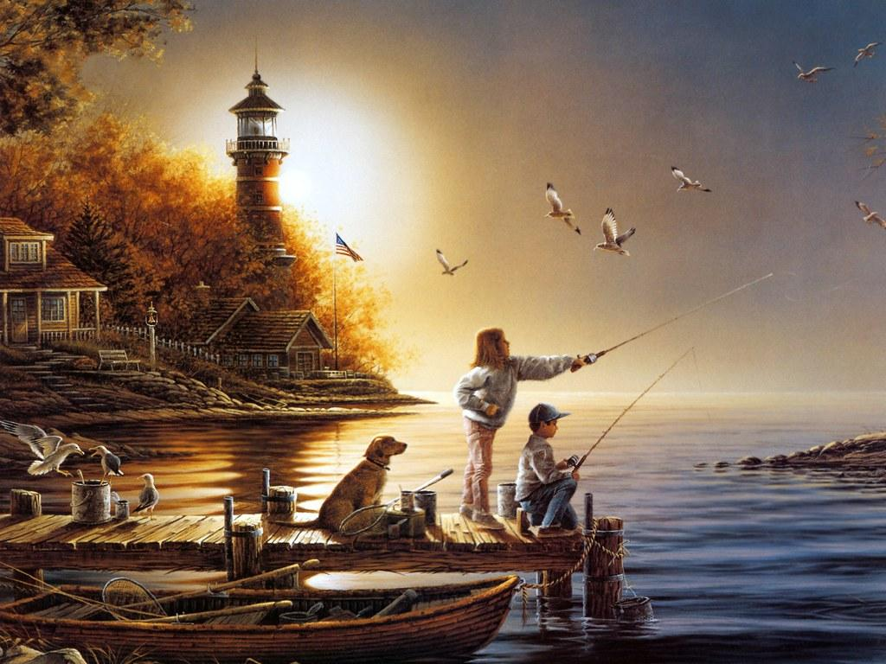

|  |  |  |
| --- | --- | --- |
|  | **Teacher** | Brittany Gullison |
| **School** | Sir J. B. Smith High School |
| **Subject** | English |
| **Grade** | 9 |
| **Date** | 25/02/12 |

|  |  |
| --- | --- |
| **Lesson Goal:**   * Introduce the characteristics of plot. * Work in whole class, cooperative groups, and individually to read short stories. * Demonstrate an understanding of plot structure by analyzing a several short stories. * Use Plot Diagram interactive as prewriting activity for essay tracing plot structure in a short story. | Summative Assessment:   The End Product – The Student’s Finalized Narrative.  Formative Assessment:  Have students demonstrate their abilities to pick out the elements of plot from a pre-existing narrative/short story.  Students will use the Elements of the plot diagram in order to place the events in the story in sequence. Students will be able to work individually or in pairs.  SEE PLOT DIAGRAM AND ACTIVITY HANDOUT |
| **Title of Lesson: Introduction to Plot** | |
| **Curriculum Outcome:** Create an organizing structure appropriate to the purpose, audience, and context of texts. | |
| **Assessment (Product):** | |
| **Materials: Elements of Plot PowerPoint, Short Story “The Flower”, numerous short stories for students, plot diagram and handout.**  **Vocabulary:  Plot**  **Introduction**  **Rising Action Climax**  **Falling Action**  **Resolution** | |
| **Logistics/Relationships: For the activity sheet students will be given the option to work independently on their own or they can pair up into small groups of 2-3.** | |
| **Procedure for class:**  1. Introduce students to plot structure, using the [Elements of Plot PowerPoint Presentation](http://www.readwritethink.org/lesson_images/lesson401/PlotStructure.pps" \t "_blank).  This power point includes the key terms and elements of plot as well as gives students the visual  representation of the Plot Diagram.  2. Next, as a class, read ["The Flowers" by Alice Walker](http://theliterarylink.com/flowers.html" \t "_blank). Available at http://theliterarylink.com/flowers.html.  3. Ask students to brainstorm the significant events in the story. As students make suggestions, write the events on the board.  4. When students finish making suggestions, review the list. Ask students to look for any events that have been taken out or items that should be combined.  5. Discuss the difference between significant events and the other events in the story. Remind students of the information from the [Elements of Plot PowerPoint Presentation](http://www.readwritethink.org/lesson_images/lesson401/PlotStructure.pps" \t "_blank), particularly the connections between the plot and the conflict in the story.  6. As a class, arrange the events of the plot, using the [Plot Diagram](http://www.readwritethink.org/materials/plot-diagram/" \t "_blank) (<http://www.readwritethink.org/files/resources/interactives/plot-diagram>) student interactive, and discussing the literary terms of exposition, rising action, climax, falling action, and resolution. 7. Students will then be given time to complete the activity sheet individually or in small groups   of 2-3. 8. Once the students have completed the sheet they are to use the remainder of the period to work   on their narratives. | |
|  | |

"The Flowers" by Alice Walker

Reading and Writing about Short Fiction. Ed. Edward Proffitt. NY: Harcourt,  
1988. 404-05.

It seemed to Myop as she skipped lightly from hen house to pigpen to smokehouse that the days had never been as beautiful as these. The air held a keenness that made her nose twitch. The harvesting of the corn and cotton, peanuts and squash, made each day a golden surprise that caused excited little tremors to run up her jaws.

Myop carried a short, knobby stick. She struck out at random at chickens she liked, and worked out the beat of a song on the fence around the pigpen. She felt light and good in the warm sun. She was ten, and nothing existed for her but her song, the stick clutched in her dark brown hand, and the tat-de-ta-ta-ta of accompaniment,

Turning her back on the rusty boards of her family's sharecropper cabin, Myop walked along the fence till it ran into the stream made by the spring. Around the spring, where the family got drinking water, silver ferns and wildflowers grew. Along the shallow banks pigs rooted. Myop watched the tiny white bubbles disrupt the thin black scale of soil and the water that silently rose and slid away down the stream.

She had explored the woods behind the house many times. Often, in late autumn, her mother took her to gather nuts among the fallen leaves. Today she made her own path, bouncing this way and that way, vaguely keeping an eye out for snakes. She found, in addition to various common but pretty ferns and leaves, an armful of strange blue flowers with velvety ridges and a sweet suds bush full of the brown, fragrant buds.

By twelve o'clock, her arms laden with sprigs of her findings, she was a mile or more from home. She had often been as far before, but the strangeness of the land made it not as pleasant as her usual haunts. It seemed gloomy in the little cove in which she found herself. The air was damp, the silence close and deep.

Myop began to circle back to the house, back to the peacefulness of the morning. It was then she stepped smack into his eyes. Her heel became lodged in the broken ridge between brow and nose, and she reached down quickly, unafraid, to free herself. It was only when she saw his naked grin that she gave a little yelp of surprise.

He had been a tall man. From feet to neck covered a long space. His head lay beside him. When she pushed back the leaves and layers of earth and debris Myop saw that he'd had large white teeth, all of them cracked or broken, long fingers, and very big bones. All his clothes had rotted away except some threads of blue denim from his overalls. The buckles of the overall had turned green.

Myop gazed around the spot with interest. Very near where she'd stepped into the head was a wild pink rose. As she picked it to add to her bundle she noticed a raised mound, a ring, around the rose's root. It was the rotted remains of a noose, a bit of shredding plowline, now blending benignly into the soil. Around an overhanging limb of a great spreading oak clung another piece. Frayed, rotted, bleached, and frazzled--barely there--but spinning restlessly in the breeze. Myop laid down her flowers.

And the summer was over.

|  |  |  |
| --- | --- | --- |
|  | **Teacher** | Jason Wilson |
| **School** | Sir J B Smith High School |
| **Subject** | English Language Arts |
| **Grade** | 9 |
| **Date** |  |

|  |  |
| --- | --- |
| **Unit Goal:** For students to understand the elements of a narrative and how to effectively use them when writing. Also to write their own narratives. | **Summative Assessment:** This is one element in the final project, which is a 3-5 page narrative. |
| **Title of Mini-Lesson: Setting in Narratives** | |
| **Curriculum Outcome: -To refine writing to enhance impact.**  **-Write with purpose and understand the influence of the writer.**  **-Independently reread, add to, delete from, or reorganize the text to clarify and strengthen**  **content.** | |
| **Assessment (Product): Exit Slip – Describe what makes a setting.**  **How can you tell when or where a story takes place? Name the possible settings from the images we looked at in class (include the when and where).** | |
| **Materials: SmartBoard or projector, exit slip**  **Vocabulary: Setting, location, time, where, when.** | |
|  | |
| **Procedure for class: This mini-lesson on narrative will be largely discussion based. I have prepared four images from films set in different times and places (Blade Runner, The Good the Bad and the Ugly, Seven Samurai, and Zodiac). Prior to showing a photo on the projector, I will ask the class to offer their current understanding of what a setting is. Likely, the first answer will be something along the lines of “where the story is set.” I will then ask “what, in addition to where, makes up a setting?” I will give some thinking time and then respond to any raised hands. Hopefully, someone will offer that “when a story takes place” is an element of a setting.**  **After this has been clarified, whether a student offered the information or I provided it in the end, we will begin the discussion on the movie stills.**  **I will use a still from Blade Runner that shows a flying car and giant digital billboards. I will ask “where might this story take place?” It isn’t important that the students are correct about where Blade Runner specifically took place but that they are interpreting the image to come up with their own answer. I will follow this up by asking “when might this story take place?” I will ask the students to explain their answers. I will repeat this process with the other stills, each offering a glimpse at a different period of time and a different part of the world.**  **Following this exercise, students will have the remainder of class to work on their narratives as I do conferencing with individuals.** | |
| **Enrichment: Because it is a workshop class, those who like to work at an accelerated pace are able to do so.** | |
| **Remediation:**. **The mini-lesson lays the ground work and the exit slip gives me an understanding on who may not have grasped the lesson and who may need the information simplified.** | |
| **Teaching Strategies: Discussion, exit slip, conferencing.** | |

Setting Exit Slip (Use back of sheet if you need more room)

Describe what makes a setting.

How can you tell when or where a story takes place?

Name the possible settings from the images we looked at in class (include the when and where).

|  |  |  |
| --- | --- | --- |
|  | **Teacher** | Mr. Jesse O’Donnell |
| **School** | J. B. Smith High School |
| **Subject** | English Language Arts |
| **Grade** | 9 |
| **Date** |  |

|  |  |
| --- | --- |
| **Unit Goal:** Narrative (Short Story) | **Summative Assessment:** Polished Short Story |
| **Title of Lesson: Character Development in Narrative** | |
| **Curriculum Outcome:**  **Speaking & Listening**  **2. Students will be expected to communicate information and ideas effectively and clearly, and to respond personally and critically.**  **Reading & Viewing**  **4. Students will be expected to select, read, and view with understanding a**  **range of literature, information, media, and visual texts.**  **7. Students will be expected to respond critically to a range of texts, applying**  **their understanding of language, form, and genre.**  **Writing & Other Ways of Representing**  **8. Students will be expected to use writing and other ways of representing to**  **explore, clarify, and reflect on their thoughts, feelings, experiences, and**  **learning; and to use their imagination.**  **9. Students will be expected to create texts collaboratively and independently, using a variety of forms for a range of audiences and purposes.**  **10. Students will be expected to use a range of strategies to develop**  **effective writing and other ways of representing, and to enhance**  **clarity, precision, and effectiveness.** | |
| **Assessment (Product): Students will complete and submit the “Character Questionnaire” worksheet** | |
| **Materials:**  **“Eight Ways to Reveal Character” Handout; “Character Questionnaire” Handout; Word doc “character paintings” to be displayed on SMART board.**  **Vocabulary:** | |
| **Logistics/Relationships: Whole Class Discussion & Independent Seatwork/Peer-review** | |
| **Procedure for class:**  **Phase 1:**  **Distribute student portfolios, the “Eight Ways to Reveal Character” handout, and “Character Questionnaire” handout. Then, randomly select individual students to read each section of the “Eight ways to Reveal Character” handout aloud, expanding on how each example serves its purpose. (15 minutes)**  **Phase 2:**  **Display Word document titled “character paintings” on the SMART Board, discuss each painting, and discuss possible topics for their short story writing assignment that the paintings inspire. (10 minutes)**  **Phase 3: Have students complete “Character Questionnaire” Handout and submit by the start of next class. (TBD)**  **Phase 4:**  **Have students work on their short story assignment (this may be actual writing or peer-review of each other’s drafts). Conference with students. (TBD)** | |
| **Enrichment: Peer-review/practicing writing** | |
| **Remediation:** **Conferencing** | |
| **Teaching Strategies: Whole-Class Discussion & Workshop Approach** | |

**Eight Ways to Reveal Character**

**Actions**

As Kevin moved down the street his feet made a steady echo sound against the pavement. He whistled despite the loud rumble of the traffic and the car horns. When someone yelled out the window of his or her car to watch where he was going, he just waved back like he was watching a best friend heading home. He passed by the garbage on the sidewalk and the old woman pushing the shopping cart filled with newspaper, and continued to smile as he headed toward Cindy’s house. Nothing could erase that smile from his face, not even the coldness of the streets he called home.

**Dialogue**

“I ain’t gonna leave you here, Ma’am . . . not with you needin’ help and all,” Jimmy said as he walked back to his truck to get the jack. “I’d help anybody who needed it; my momma taught me better’en to just leave people. The good Lord’ll make it up to me.”

**Physical Description**

Other guys walking through the hallway were taller and even more handsome, but there was something about Billy Belaire. His arms swung loose at his side and his dark hair was long and pulled back behind his head, held by a rubber band. The dark jacket he wore was straight out of the local thrift shop, she could tell, but the way he wore it suggested a sense of pride, or at least a lack of caring what others thought about him.

**Idiosyncrasies**

Junior tapped his fingertips against the table and looked at his watch constantly. His leg bounced up and down and he gulped the hot coffee as if it would hurry up his friend’s arrival.

**Objects/Possessions**

Michael touched the locket around his neck and rolled it between his fingers. His mother had given him that locket, with her picture inside, when he had left to live with his father. What would she think of him now?

**Reactions**

Tony’s words stung Laura. It wasn’t what she expected to hear. They had been dating for over a month now, how could he do this to her? How could he break her heart? All three of their dates had been fun; he had said so himself. As Tony watched the floodgate of her eyes begin to open he looked at his watch. *Jeez, I hope I can make it to the gym on time.*

**Thoughts**

He began to remember when he was a freshman in high school. The seniors really thought they were something back then, always trying to play their little pranks on the ninth graders. He knew at that moment he couldn’t be one of those kinds of people. He walked over to Jeff and Larry to tell them it was time to stop.

**Background Information**

Miles knew what it meant to be alone. When he was a child growing up his father had been in the military. They had traveled from Florida, to Georgia, to California, to Kentucky. He had rarely had a friend for very long. By the leap from California he had already decided having friends was a risk; the fewer the friends, the easier it was to leave. This philosophy had made him a real outsider at Glenview High School. In the six months he had been there he had not really made a single friend but as he stood there staring at Sheila, he realized that just might have to change.

[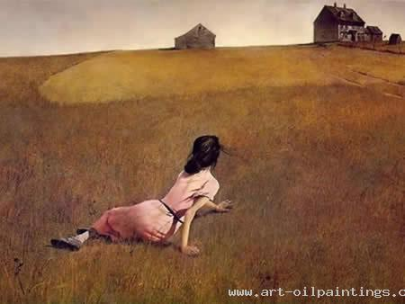](http://www.art-oilpaintings.com/uploadfile/product/character-paintings-chinese-character/Chinese-character-painting-7--1278372655-0.jpg)

[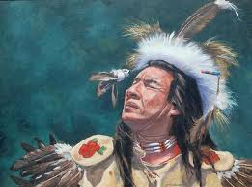](http://www.google.ca/imgres?q=character+paintings&hl=en&biw=1366&bih=673&gbv=2&tbm=isch&tbnid=D52rzv0zXEMEIM:&imgrefurl=http://freepages.misc.rootsweb.ancestry.com/~jpcfamily/people.htm&docid=qp6unHSL2rWrPM&imgurl=http://freepages.misc.rootsweb.ancestry.com/~jpcfamily/images/people/prelude-18X24.jpg&w=1024&h=758&ei=bO1HT6viEYHx0gGaovmCDg&zoom=1)

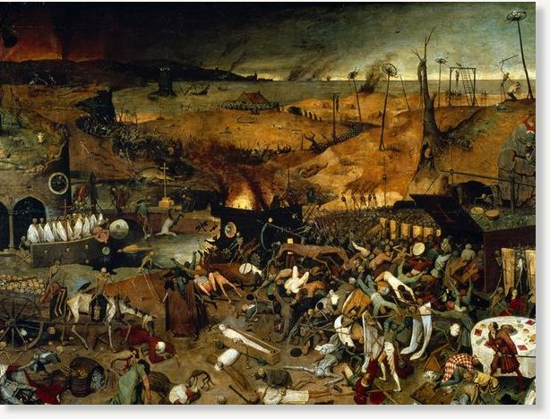

Student Name: \_\_\_\_\_\_\_\_\_\_\_\_\_\_\_\_\_\_\_\_\_\_\_\_\_\_\_\_\_\_\_\_\_\_\_\_ Grade 9 English

***Character Questionnaire***

Answer each of the questions below to develop a character that you might want to use in a short story. Be as specific as possible.

1) What is your character’s name? Does the character have a nickname?

2) What is your character’s hair color? Eye color?

3) What kind of distinguishing facial features does your character have?

4) Does your character have a birthmark? Where is it? What about scars? How did he get them?

5) Who are your character’s friends and family? Who does she surround herself with? Who are the people your character is closest to? Who does he wish he were closest to?

6) Where was your character born? Where has she lived since then? Where does she call home?

7) Where does your character go when he’s angry?

8) What is her biggest fear? Who has she told this to? Who would she never tell this to? Why?

9) Does she have a secret?

10)What makes your character laugh out loud?

11)When has your character been in love? Had a broken heart?

12)What is in your character’s refrigerator right now? On her bedroom floor? On her nightstand? In her garbage can?

13)Look at your character’s feet. Describe what you see there. Does he wear dress shoes, gym shoes, or none at all? Is he in socks that are ratty and full of holes? Or is he wearing a pair of blue and gold slippers knitted by his grandmother?

14)When your character thinks of her childhood kitchen, what smell does she associate with it? Sauerkraut? Oatmeal cookies? Paint? Why is that smell so resonant for her?

15)Your character is doing intense spring cleaning. What is easy for her to throw out? What is difficult for her to part with? Why?

16)It’s Saturday at noon. What is your character doing? Give details. If he’s eating breakfast, what exactly does he eat? If she’s stretching out in her backyard to sun, what kind of blanket or towel does she lie on?

17)What is one strong memory that has stuck with your character from childhood? Why is it so powerful and lasting?

18)Your character is getting ready for a night out. Where is she going? What does she wear? Who will she be with?

|  |  |  |
| --- | --- | --- |
|  | **Teacher** | Melissa Smith |
| **School** | Sir J B Smith High School |
| **Subject** | English |
| **Grade** | 9 |
| **Date** | 28 February 2012 |

|  |  |
| --- | --- |
| **Unit Goal:**  Students will develop an understanding of the process, skills and elements of writing a short story narrative.  They will apply the regular mechanics and conventions of writing.  Students will work collaboratively with peers in a peer review process and teacher student conferencing. They will also experience the writing process of submitting outlines and drafts, editing and revising, before submitting a completed copy | **Summative Assessment:**  Students will submit a 3-5 page narrative story at the end of the term that will be assessed on a rubric (See Evaluation section) |
| **Title of Lesson:** Introduction to Conflict | |
| **Curriculum Outcome:**  *General Curriculum Outcomes:* Students will be expected to use a range of strategies to develop  effective writing and other ways of representing, and to enhance clarity, precision, and effectiveness.  *Specific Curriculum Outcomes:* analyse and reflect on others’ responses to their writing and audiovisual productions and consider those responses in creating new pieces  Consistently use the conventions of written language in final products | |
| **Assessment (Product):** Informal formative assessment through opening discussion | |
| **Materials:** conflict prezi <http://prezi.com/opbxes8xy6re/writing-with-conflict/>, excerpt from *The Tell Tale Heart* by Edgar Allan Poe, link to video of dramatic reading.  **Vocabulary:** conflict, internal/external conflict | |
| **Logistics/Relationships:** students work independently on their projects; peer conferencing; student-teacher conferencing. | |
| **Procedure for class:**   1. Warm-up activity (10 minutes): Read students an excerpt from *The Tell Tale Heart*. At this point they have had minilessons on plot development, setting, character and conflict Ask guiding questions and discuss to get students thinking about conflict. What has happened in the excerpt read? What is the setting like? Who are the characters and what do we know about them? How do you think they feel? Are there any challenges or struggles in the story? What are they and who does it affect? Does the events of the story, location or personality of the characters involved influence the development of this struggle?   Optional: show video of a dramatic reading of the selected section of *The Tell-Tale Heart* <http://www.youtube.com/watch?v=2LNjgv5p3Ek>   1. Instruction on conflict: Begin power point presentation   Explain to students that they have been learning how to develop and apply elements of plot, character and setting in their narrative pieces. All four of these elements influence each other, especially conflict.  Take a couple minutes and discuss your favorite book, movie or the excerpt and think about what takes place and where (if a story is set in a certain place in a certain time period, the events of the story and the social atmosphere of the location mentioned might impact the experiences and development of character and conflict. Think about what is going on in your painting and the story you are creating. What are the challenges and struggles taking place and what is causing them?  Conflict: a struggle or opposition between characters or within the main character that drives the action of the story. <http://www.merriam-webster.com/dictionary/conflict>  Think about the conflicts that exist in the texts you discussed, your story or *The Tell-Tale Heart*. The conflict drives the story. Think about those examples again and imagine what would happen without those conflicts.  There are two types of conflict: external conflict is the struggles the main character has with another character or society. External conflicts include man versus man and man versus society. Can anyone give an example of external conflict?  Internal conflict is the struggles a character experiences within themselves. This includes man versus himself/herself. It can be caused by the characteristics of the character or external factors like society and circumstances can cause the character to feel an internal struggle. In the story read at the beginning of class the character does not have any reason to want to kill the old man, but the psychological impact the man’s gaze from his “vulture eye” has on the narrator causes an internal conflict.  Conflict in a story is followed by the climax. The climax occurs when events and actions have escalated to a point that an action occurs that symbolizes the “no turning back now” point of the story. What would be the climax in TTTH? When he finally kills the old man, he cannot undo the deed and must live with whatever actions follow.  Another element of developing conflict is resolution. The resolution is how the conflict is resolved. This can be resolved in a way that produces a happy ending or tragedy. Sometimes the conflict may not be resolved.  When writing your texts consider each of the elements you have already learned about and think about what conflict exists in your story. Think about the character(s) and what they experience, the setting, the other people they encounter.   1. Students have the remainder of class to work on their personal narratives | |
| **Enrichment:** Student are working on a multi-step project. If someone finishes early then they move on to the next task once the teacher has determined that requirements for the stages is complete | |
| **Remediation:** Providing audio samples by reading aloud a text, peer discussion on relatable subjects. | |
| **Teaching Strategies:** Audio instruction, power point presentation | |

**The Tell-Tale Heart**

**By Edgar Allan Poe**

It is impossible to say how first the idea entered my brain; but once conceived, it haunted me day and night. Object there was none. Passion there was none. I loved the old man. He had never wronged me. He had never given me insult. For his gold I had no desire. I think it was his eye! yes, it was this! He had the eye of a vulture --a pale blue eye, with a film over it. Whenever it fell upon me, my blood ran cold; and so by degrees --very gradually --I made up my mind to take the life of the old man, and thus rid myself of the eye forever.   
   Now this is the point. You fancy me mad. Madmen know nothing. But you should have seen me. You should have seen how wisely I proceeded --with what caution --with what foresight --with what dissimulation I went to work! I was never kinder to the old man than during the whole week before I killed him. And every night, about midnight, I turned the latch of his door and opened it --oh so gently! And then, when I had made an opening sufficient for my head, I put in a dark lantern, all closed, closed, that no light shone out, and then I thrust in my head. Oh, you would have laughed to see how cunningly I thrust it in! I moved it slowly --very, very slowly, so that I might not disturb the old man's sleep. It took me an hour to place my whole head within the opening so far that I could see him as he lay upon his bed. Ha! would a madman have been so wise as this, And then, when my head was well in the room, I undid the lantern cautiously-oh, so cautiously --cautiously (for the hinges creaked) --I undid it just so much that a single thin ray fell upon the vulture eye. And this I did for seven long nights --every night just at midnight --but I found the eye always closed; and so it was impossible to do the work; for it was not the old man who vexed me, but his Evil Eye. And every morning, when the day broke, I went boldly into the chamber, and spoke courageously to him, calling him by name in a hearty tone, and inquiring how he had passed the night. So you see he would have been a very profound old man, indeed, to suspect that every night, just at twelve, I looked in upon him while he slept.   
   Upon the eighth night I was more than usually cautious in opening the door. A watch's minute hand moves more quickly than did mine. Never before that night had I felt the extent of my own powers --of my sagacity. I could scarcely contain my feelings of triumph. To think that there I was, opening the door, little by little, and he not even to dream of my secret deeds or thoughts. I fairly chuckled at the idea; and perhaps he heard me; for he moved on the bed suddenly, as if startled. Now you may think that I drew back --but no. His room was as black as pitch with the thick darkness, (for the shutters were close fastened, through fear of robbers,) and so I knew that he could not see the opening of the door, and I kept pushing it on steadily, steadily.   
   I had my head in, and was about to open the lantern, when my thumb slipped upon the tin fastening, and the old man sprang up in bed, crying out --"Who's there?"   
   I kept quite still and said nothing. For a whole hour I did not move a muscle, and in the meantime I did not hear him lie down. He was still sitting up in the bed listening; --just as I have done, night after night, hearkening to the death watches in the wall.   
  ...   When I had waited a long time, very patiently, without hearing him lie down, I resolved to open a little --a very, very little crevice in the lantern. So I opened it --you cannot imagine how stealthily, stealthily --until, at length a simple dim ray, like the thread of the spider, shot from out the crevice and fell full upon the vulture eye.   
   It was open --wide, wide open --and I grew furious as I gazed upon it. I saw it with perfect distinctness --all a dull blue, with a hideous veil over it that chilled the very marrow in my bones; but I could see nothing else of the old man's face or person: for I had directed the ray as if by instinct, precisely upon the damned spot.

Sample Student Projects

Sample Painting Plot Descriptions

*This is a sample of what students would develop for the in-class activity in the introductory class.*

1. After their car breaks down during a back-road road trip, Mary and Ashley push their car to the closest house. As the moon rises in the distant sky a massive house is in the distance. No one appears to be home, it might be abandoned. The girls break in to stay the night before moving on in the morning. As the night moves on, they realize they might not be alone after all.
2. Jerry has had troubles with drugs and alcohol and lost his daughter in his divorce. He carries a photograph of better days with him and his baby daughter on the beach as he tries to fix the wreckage of his life.
3. A single mother in the 1800s tries to keep her children healthy and safe while living in the streets of London.
4. There is a civil war memorial cemetery where ghosts of fallen soldiers arrive on horseback once per year. No one has ever gotten close enough to see if they are dangerous or simply apparitions.
5. The wood is home to many as the village elders host a party for three youngsters, Jericho, Perigryn, and Uster before they begin their trials of adulthood in a year-long journey through the distant mountain range.
6. Jacob and his parents have a cabin. They visit it for a week in the fall every year. Jacob has made friends with a young deer but what happens when hunters come on the scene?
7. Stranded on a strange planet with no memory of how he got there, Kurt Irving wanders the barren wastelands looking for answers. On the way he is greeted with mortal danger and monsters unlike anything he has ever imagined.
8. Two youths of affluence share a bond by the water. She is arranged to be married but has fallen in love with her new compatriot.
9. People are dead, the war is far from over and one soldier has hidden. He hates himself for his cowardice but is grateful for surviving. His troubles are not over as he must escape the warzone without getting caught by either side.
10. Washing dishes in the farmhouse after a family brunch, Tom and Mary are oblivious of the young woman crawling toward their house. They bring her into the house when they do. She’s sweating, pale and has what looks like human bitemarks on her skin.
11. Not wishing to stay home in a life of servitude and boredom, the young lady leaves her family under the cloak of night, purchases a boat and sails down river toward an adventurous new life.
12. Strange people are near. No one has invaded this land before. Debate arises among the villagers regarding whether the new people should be welcomed or killed.

Plot Diagram for Lesson on Plot

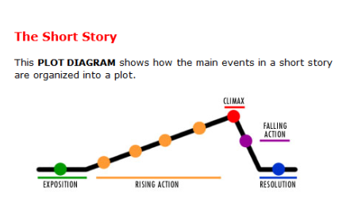

Student Name: \_\_\_\_\_\_\_\_\_\_\_\_\_\_\_\_\_\_\_\_\_\_\_\_\_\_\_\_\_\_\_\_\_\_\_\_ Grade 9 English

***Character Questionnaire***

Answer each of the questions below to develop a character that you might want to use in a short story. Be as specific as possible.

**1) What is your character’s name? Does the character have a nickname?**

My character’s name is Neil Rakers. He has no nickname.

**2) What is your character’s hair color? Eye color?**

His eyes and hair are brown.

**3) What kind of distinguishing facial features does your character have?**

He has a chiselled jaw, a receding hairline, and a big red beard.

**4) Does your character have a birthmark? Where is it? What about scars? How did he get them?**

He has a scar across cheek from a bar fight.

**5) Who are your character’s friends and family? Who does he surround herself with? Who are the people your character is closest to? Who does he wish he were closest to?**

His wife, the daughter of a capitalist fat cat, is deceased and his son, Mitchell, is homeless and Neil rarely sees him. He surrounds himself with people at the local bar, but he stays home a lot, too. He is closest to the bar owner, Mel (even though Mel secretly wishes he would stop coming around), but he wants to reconnect with his son so they can be together and help each other get back on their feet.

**6) Where was your character born? Where has he lived since then? Where does he call home?**

Neil was born in New Jersey and lived there his whole life. He met his wife while working at the docks in New York City, and she moved to New Jersey to be with him

**7) Where does your character go when he’s angry?**

When Neil is angry he just sits in his basement punching a punching bag.

**8) What is his biggest fear? Who has he told this to? Who would he never tell this to? Why?**

Neil’s biggest fear is failure. Even though his wife is dead, he still feels he has to prove to his parents-in-law that he worthy of his daughter. He told this to Mel, the bar owner, but he probably wouldn’t tell anyone else because there is no one else to listen. He wants his son, Mitchell, to tell him he was a good father, but Mitchell is so disconnected that he probably wouldn’t even listen to his insecurities.

**9) Does he have a secret?**

Neil has been getting sicker and sicker with cancer. He doesn’t have insurance, so he can’t afford to go for treatment. He hasn’t told a soul about his illness.

**10) What makes your character laugh out loud?**

Neil laughs at jokes he hears at the bar, but he is never part of the conversation so the other customers either lower their voices or just move to a different seat. Other than that, Neil doesn’t laugh very much.

**11)When has your character been in love? Had a broken heart?**

Neil was only in love with his wife and he has been broken-hearted ever since she died last spring. They met when he was 21 and she was 17. He had never even kissed a girl before that. He’s now forty years old.

**12) What is in your character’s refrigerator right now? On his bedroom floor? On his nightstand? In his garbage can?**

Neil’s fridge contains a six-pack of beer, a plate of raw hotdogs, and a jar of mustard. His bedroom floor is covered with dirty clothes, old plates of food, and empty beer bottles. His nightstand has an ashtray, empty beer bottles, a lamp, and a photo album of his wedding day on it. His garbage can is overflowing, just like it always is.

**13) Look at your character’s feet. Describe what you see there. Does he wear dress shoes, gym shoes, or none at all? Is he in socks that are ratty and full of holes? Or is he wearing a pair of blue and gold slippers knitted by his grandmother?**

Neil wears torn wool socks and extremely worn-out work boots that are covered in tar, even though he hasn’t worked in a year.

**14) When your character thinks of his childhood kitchen, what smell does he associate with it? Sauerkraut? Oatmeal cookies? Paint? Why is that smell so resonant for him?**

Every kitchen in every house that Neil ever lived in seemed to smell the same; they all smelled like rotted food.

**15) Your character is doing intense spring cleaning. What is easy for him to throw out? What is difficult for him to part with? Why?**

Neil has a hard time throwing anything out. He always sees a piece of his wife in everything. When he throws something out, it is usually because it smells so bad that even he can’t stand it.

**16) It’s Saturday at noon. What is your character doing? Give details. If he’s eating breakfast, what exactly does he eat? If he’s stretching out in her backyard to sun, what kind of blanket or towel does she lie on?**

Neil is just getting out of bed. It’s the summer, so he’s so hot that he needs to take a shower before anything else. Then he heads to the bar to have a beer for breakfast and he will probably be there until closing time.

**17) What is one strong memory that has stuck with your character from childhood? Why is it so powerful and lasting?**

Neil will always remember when his parents got divorced. He loved them both equally and hated to have to choose one to live with. He specifically remembers the day his father left (Neil stayed with his mother). As the old pickup truck rolled down the street, Neil, a boy of just eight, hoped he hadn’t hurt his Dad’s feelings.

**18) Your character is getting ready for a night out. Where is he going? What does he wear? Who will he be with?**

Neil goes to the bar every Saturday and stays all day and night. He wears a white, stained t-shirt that is very stretched and an unbuttoned flannel work shirt. His jeans are ruined by grease stains and torn up at the knees. He will mostly sit and watch television (his cable was disconnected a while ago) and sip away at a beer. Sometimes he talks to people that sit close to him, but usually Mel is the only person who listens at all.

Narrative

Materials/Resources

**Introductory Lesson**

-Prezi Presentation <http://prezi.com/lhcjggeco4gp/introduction-to-narrative-unit/>

-Mind Map template (see lesson plan)

-12 paintings/images for narrative piece (below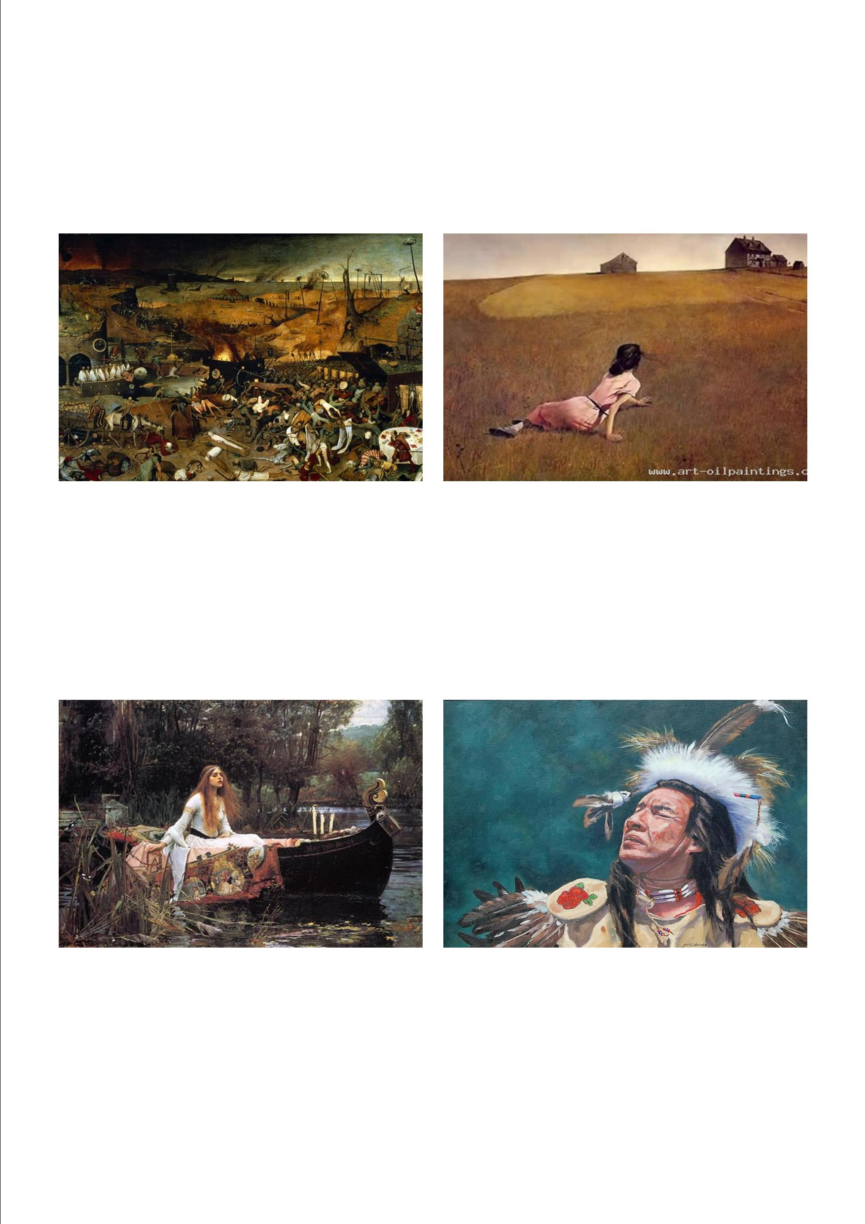

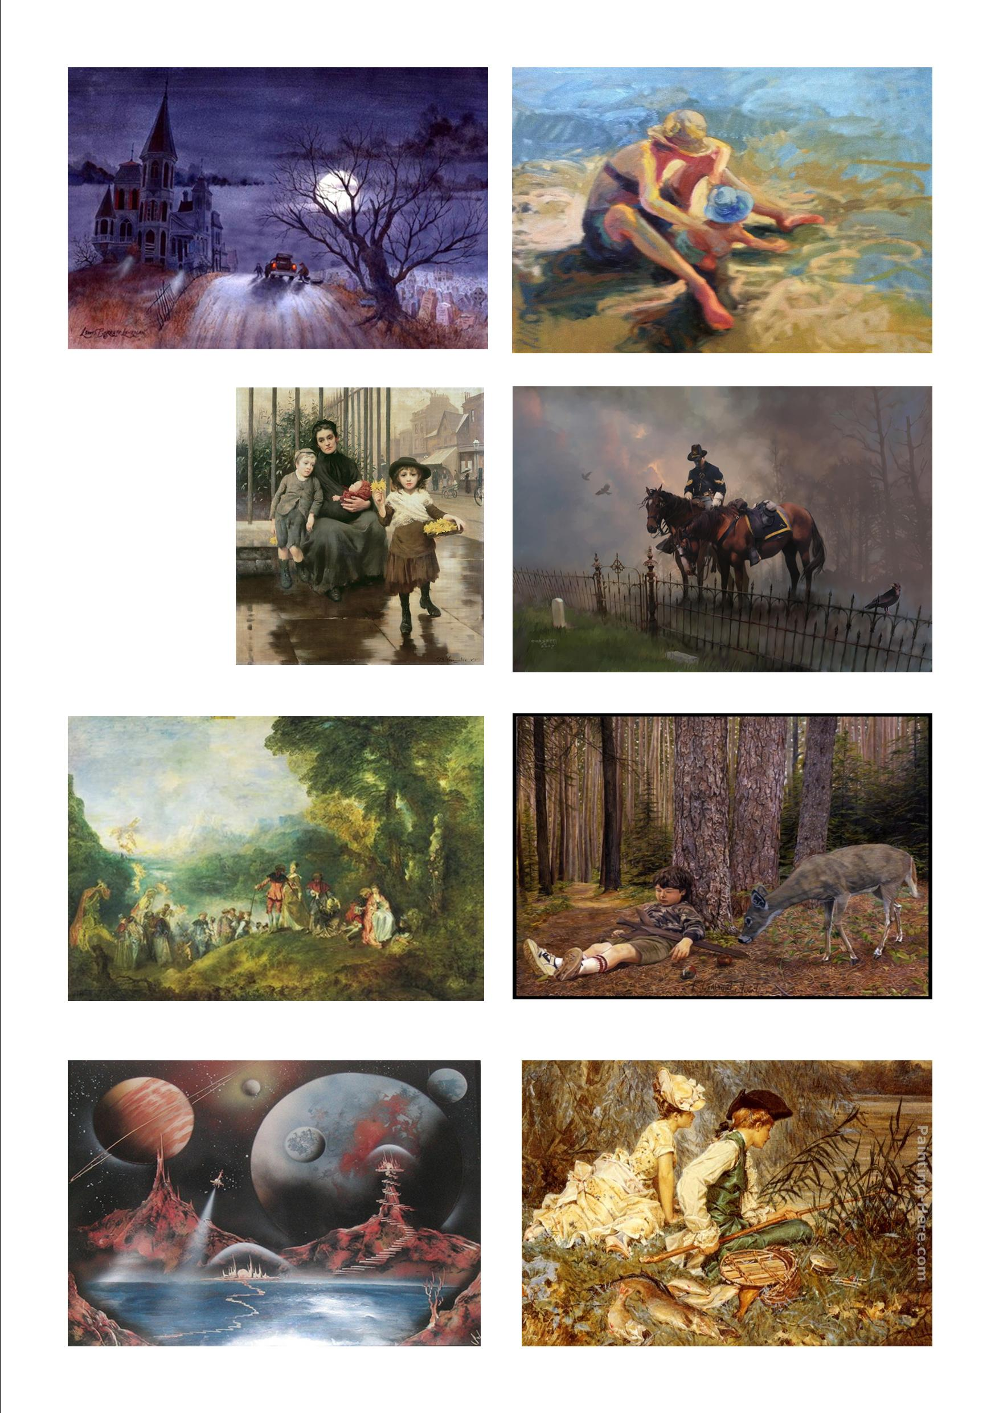

Penny Kittle’s book *Write Beside Them* provides useful information for teachers or writing classes on how to organize writing units and structure workshop classes.

In terms of planning for writing units, Kittle suggests that teachers begin the term with a unit on story because it is the most accessible to writers. Students each have their own memories and experiences that provide them with a starting point for developing a story. Kittle explains that story allows young writers to get confidence and an authoritative voice on paper. This introductory unit allows teachers to instruct students on how to organize, give structure to an idea and connect it to a theme. Students will also be encouraged and instructed on reviewing and revising their work and the work of others.

The second unit, which resembles the unit we have designed, focuses on a more advanced, themed story. This unit encourages development of dialogue, smoother transition and developments in other areas of writing. This unit focuses on three elements of writing: the snapshot moment; the first narrative; then the extended narrative.

Kittle also has a chapter on opportunities in a writers workshop where she focuses on how to structure a workshop class. On page 70 of the chapter she proposed an agenda for a class. Begin by introducing a daily agenda, silent reading, quick writes, minilessons, writing workshop and sharing pieces of work at the end of class

**Plot Development Lesson Plan**

**Reader’s Guide to Understanding**

**Plot Development**

1.What is the conflict in this story? How does the writer present the problem between the protagonist and antagonist?

2.What do you learn in the exposition or introduction of the story?

3.What events are included in the rising action of the story?

4.What is the climax of the story?

5.What events are included in the falling action of the story?

6.How is the conflict resolved?

7.How does the writer use suspense in developing the plot of this story?

**Lesson on Character Development**

Student Name: \_\_\_\_\_\_\_\_\_\_\_\_\_\_\_\_\_\_\_\_\_\_\_\_\_\_\_\_\_\_\_\_\_\_\_\_ Grade 9 English

***Character Questionnaire***

Answer each of the questions below to develop a character that you might want to use in a short story. Be as specific as possible.

1) What is your character’s name? Does the character have a nickname?

2) What is your character’s hair color? Eye color?

3) What kind of distinguishing facial features does your character have?

4) Does your character have a birthmark? Where is it? What about scars? How did he get them?

5) Who are your character’s friends and family? Who does she surround herself with? Who are the people your character is closest to? Who does he wish he were closest to?

6) Where was your character born? Where has she lived since then? Where does she call home?

7) Where does your character go when he’s angry?

8) What is her biggest fear? Who has she told this to? Who would she never tell this to? Why?

9) Does she have a secret?

10)What makes your character laugh out loud?

11)When has your character been in love? Had a broken heart?

12)What is in your character’s refrigerator right now? On her bedroom floor? On her nightstand? In her garbage can?

13)Look at your character’s feet. Describe what you see there. Does he wear dress shoes, gym shoes, or none at all? Is he in socks that are ratty and full of holes? Or is he wearing a pair of blue and gold slippers knitted by his grandmother?

14)When your character thinks of her childhood kitchen, what smell does she associate with it? Sauerkraut? Oatmeal cookies? Paint? Why is that smell so resonant for her?

15)Your character is doing intense spring cleaning. What is easy for her to throw out? What is difficult for her to part with? Why?

16)It’s Saturday at noon. What is your character doing? Give details. If he’s eating breakfast, what exactly does he eat? If she’s stretching out in her backyard to sun, what kind of blanket or towel does she lie on?

17)What is one strong memory that has stuck with your character from childhood? Why is it so powerful and lasting?

18)Your character is getting ready for a night out. Where is she going? What does she wear? Who will she be with?

**Lesson Plan for Conflict**

**Conflict in Short Stories**

While there are many elements to any short story, one of the most important to consider while writing is conflict. As we write stories, characters and their development can take radical turns even during the creation process. Often even the final plot and theme barely resemble what we originally intended, changing dramatically once we “put pen to paper”. Rarely, however, do we stray far from the conflict we had in mind. I have always felt that characters are pliable, you can mold them to do what you want. Change a character trait and you have altered a story’s path all the while heading in the same direction. Conflict is foundational. Change the conflict and you are on a new road altogether. I would argue that, outside of the point of view that we select for a story, most of the time spent thinking about our tale should focus on the conflict of the story and its ultimate resolution. Because of its importance, it is my opinion that conflict should be considered a particular element all its own and not just subsumed by plot.  
  
So what is conflict? Simply put, it is the struggle between opposing forces. As you will see, I also believe that there is one main factor which captures the essence of conflict, but we’ll come to that in a minute. First, we need the basics.  
  
Any Google search regarding conflict in short stories will garner you decent results. I gleaned the following from **[http://hrsbstaff.ednet.ns.ca/engramja/elements.html:](http://www.Writing.Com/main/redirect.php?redirect_url=http://hrsbstaff.ednet.ns.ca/engramja/elements.html:" \t "_blank)**  
  
**There are two *types* of conflict:**   
  
1) *External* - A struggle with a force outside one's self.  
2) *Internal* - A struggle within one's self; a person must make some decision, overcome pain, quiet their temper, resist an urge, etc.   
  
**There are four *kinds* of conflict:**   
  
1) *Man vs. Man (physical)* - The leading character struggles with his physical strength against other men, forces of nature, or animals.   
2) *Man vs. Circumstances (classical)* - The leading character struggles against fate, or the circumstances of life facing him/her.   
3) *Man vs. Society (social)* - The leading character struggles against ideas, practices, or customs of other people.   
4) *Man vs. Himself/Herself (psychological)* - The leading character struggles with himself/herself; with his/her own soul, ideas of right or wrong, physical limitations, choices, etc.   
  
As you work the details of your story, ask yourself “What makes for a good conflict?” When you develop your conflict keep in mind what the driving force is behind the struggle. What pushes the character in your story to overcome whatever obstacles get in his/her way, and why do we, as the reader, need to understand and care about those struggles? Make the conflict appealing by revealing, through characterization and narration, what the basis for the struggle actually is. And what lies behind conflict can be summarized by one word: Want.   
  
It is one of our many jobs as authors to create situations where our characters crave something and then thwart, either temporarily or permanently, those needs. Realizing that why we care about a character has more to do with understanding what they desire than with their appearance or their mannerisms will result in a better crafted tale. What is important is that by making a character’s wishes clear and having them resonate with your reader you will naturally write more compelling stories and cause your readers to ask that all important question: “What happens next?”  
  
Make every character want something. It is what drives the action from one point to another. Even the flattest of characters should need something, should have some purpose, whether it's something to eat or the need to leave the scene. By creating and frustrating a character's needs, you impart flow to the story, build suspense, and allow for a satisfying resolution, good or bad.  
  
Creating a believable conflict through the development of your characters’ needs, whether it’s your protagonists desire for life, love, or inner-peace, or your antagonists desire for power, control, or destruction, could have the biggest impact on whether or not your story is as effective as possible. Make your characters yearn!

Source: <http://www.writing.com/main/view_item/item_id/1004812-Conflict-in-the-Short-Story>

This resource is useful for the development of conflict in a piece of writing. It provides a definition and basic information about conflict in writing. This source provides information on the various types of conflict and guiding questions to consider when developing conflict and for teachers instructing students on this skill.

Bibliography

Hensley, D. (2000). Eight Ways to Reveal Character. *Teaching the Short Story: Teacher’s*

*Packet.* Retrieved from <http://www.ket.org/education/guides/pd/teachingtheshortstory.pdf>

Kittle, Penny. (2008). *Write Beside Them*. USA:Heinemann Educational Books

writingclasses.com. (2012). Character Questionnaire 1. *Character Questionnaires.* Retrieved

from <http://www.writingclasses.com/InformationPages/index.php/PageID/106>  
  
[www.readwritethink.org](http://www.readwritethink.org) (2012). Narrative Pyramid. Reader’s Guide to Plot. Retrieved from   
  
 http://www.readwritethink.org/classroom-resources/lesson-plans/teaching-plot-  
  
 structure-through-401.html?tab=5#tabs

["The Flowers" by Alice Walker](http://theliterarylink.com/flowers.html" \t "_blank). http://theliterarylink.com/flowers.html.

<http://images.wikia.com/bladerunner/images/1/18/St_bladerunner_f.jpg>  
  
<http://knightslanding.files.wordpress.com/2011/12/eastwood_good_ugly.jpg>

Poe, Edgar Allen. (2002). *The Tell-Tale Heart*. *Edgar Allan Poe Complete Tales & Poems*. Ed Wilbur S. Scott. New Jersey: Castle Books  
  
<http://vrhstrafilmovi.files.wordpress.com/2010/10/seven-9.jpg>  
  
<http://images.starpulse.com/Photos/Previews/Zodiac-movie-10.jpg>

<http://www.readwritethink.org/files/resources/interactives/plot-diagram>

<http://www.writing.com/main/view_item/item_id/1004812-Conflict-in-the-Short-Story>

Images

<http://www.deshow.net/d/file/cartoon/2009-05/terry-redlin-paintings-553-2.jpg>

<http://data.whicdn.com/images/10821824/Encounter_large.jpg>

<http://images.gfxartist.com/images/ArtworkItem/full/141529.jpg>

<http://www.artclon.com/OtherFile/The-Pinch-of-Poverty-1891-xx-Thomas-Benjamin-Kennington.jpg>

<http://cdn2.wn.com/pd/71/df/7284ff0cb223a6ba71d4dd75bd4f_grande.jpg>

<http://farm1.staticflickr.com/159/420732291_7d25cd8ee4.jpg>

<http://cdn1.wn.com/pd/8e/28/91074e598e817c3ae29b5c48a6d3_grande.jpg>

<http://freepages.misc.rootsweb.ancestry.com/~jpcfamily/people.htm>

<http://www.art-oilpaintings.com/Chinese-character-painting-7--387.html>

<http://science.nationalgeographic.com/science/photos/plague/>